SMA 2026 St. Pete Beach
FORMATIVE AND MULTIDIMENSIONAL MEASURES
Lisa Schurer Lambert – Texas Christian University

Explanation of Formative Measures and Multidimensional Constructs

In contrast to reflective measures which are sometimes called effect measures, formative measures, also referred to as “cause measures”, embody a fundamental difference between the construct and its indicators. The important difference is that in formative constructs, the measures or items are theorized to “cause” the construct, and the items of a formative construct are not viewed as interchangeable, equally valid indicators of the construct. Instead, formative items are viewed as causal such that increases in the indicator cause the value of the construct to increase. The items themselves form the construct. The meaning of the construct is inherent in the items. This fundamental difference between formative measures and reflective measures is seen in the direction of the arrow between the indicator and the construct. In reflective measures, the arrow goes from the construct to the indicator while in formative measures the arrow is reversed consistent with the idea that the construct is caused by the indicators.

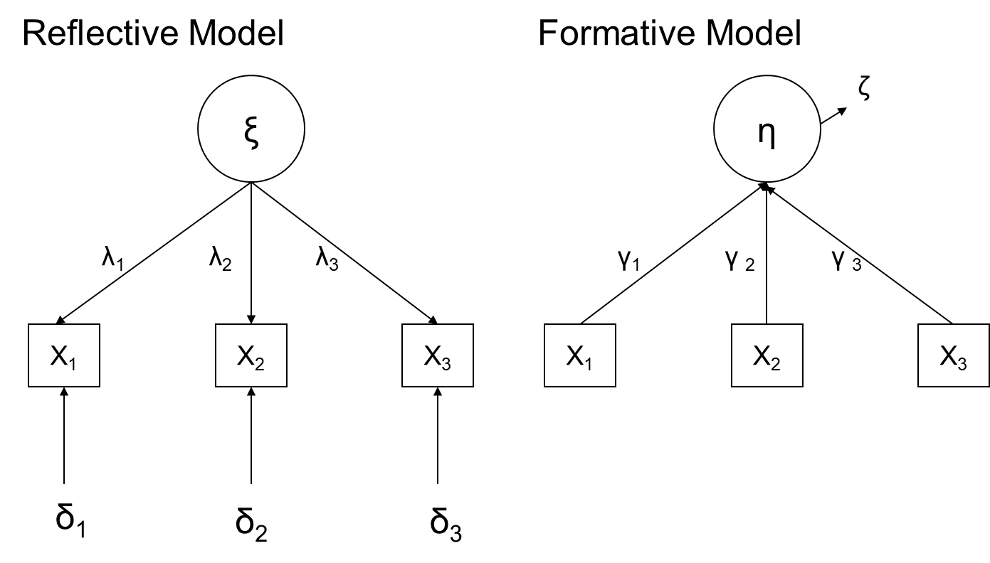

The theoretical reasoning behind formative models is that some constructs are properly caused by their indicators – that the indicators collectively constitute the construct or that the indicators combine in such a way as to cause the construct. Commonly cited examples of such formative constructs include SES (socioeconomic status composed of education, occupation and father’s occupation) or job satisfaction (satisfaction with pay, supervisor, type of work, co-workers etc.) or stress (checklist or frequency of insomnia, headaches, irritability, anxiety, depression or rapid heart rate).

Multidimensional constructs are a variation of formative constructs where the theoretical emphasis is on describing the dimensions or facets of the higher level construct. For example, organizational citizenship, as proposed by Organ (1988), was composed of civic virtue, altruism, courtesy, sportsmanship, and conscientiousness and organizational performance might be considered with the dimensions of sales, return on assets, return on investments, net income and share price. Often, the general idea is that the construct exists on a higher, more abstract level and the dimensions or facets are manifestations of aspects of the construct.

In some multidimensional constructs the scores for the facets are combined usually with an additive process, but occasionally with a multiplicative process. For other multidimensional constructs, the facet scores are kept distinct and researchers treat each facet as a distinct construct in their analyses. In yet other measures, the scores on each of the facets (or indicators) are weighted, perhaps with scores obtained from principal components analysis or a related technique, and then added to form a composite score to represent the construct. The distinctions between these types may have important theoretical consequences and should be precisely specified and supported by empirical evidence. Some work has been done to describe types of multidimensional constructs and these authors urge researchers to carefully and theoretically define the relationships between indicators, dimensions and constructs.

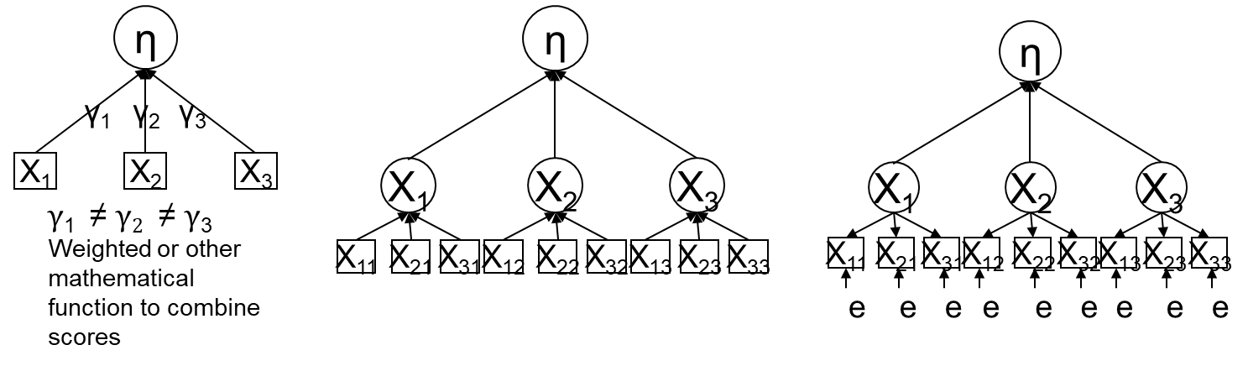

Advantages of formative measurement

Advocates of formative or multidimensional measures argue that this approach correctly represents the relationship between indicators and their constructs – that the indicators cause the construct. The claim is that ignoring those causal processes is false and would lead to dropping many useful and commonly used measures. In other statements, there is less emphasis on causal relationships and the focus is on how the indicators, or dimensions, combine in some fashion to create the meaning of the construct. In either case, the implication is that these relationships exist and should be represented as formative measures.

There are consequences to theorizing and using a formative measure:

- Internal consistency among items for a measure is irrelevant. Correlations among items may be high or low in any pattern rendering the Cronbach’s alpha useless as criteria for evaluating construct validity. Any analysis focusing on covariance among the items is unnecessary and there are no hurdles for establishing adequate internal consistency (e.g., Cronbach’s alpha is irrelevant).

- To establish construct validity with reflective measures it is necessary to show that items within a construct correlation more highly with each other than with items from other constructs. Given that there is no necessity for formative items to correlate with each other, there is also no requirement to establish that the correlation of formative items with items from other constructs is lower than within construct correlations. However, the formative construct should still be different from other constructs, i.e., show evidence of discriminant validity.

- It is imperative to adequately represent the construct’s domain by measuring the diversity of the facets or dimensions of the construct. Adding or omitting a facet or indicator changes the meaning of the construct.

- It is assumed that indicators are measured without error. Formative measures typically, but not always, measure residuals (also called disturbances) and the residual represents unexplained variance not associated with the set of indicators.

Challenges to formative measurement

There are many instances of formative and multidimensional constructs in the social sciences but their measurement models are often imprecisely articulated. Accordingly, many multidimensional models have both conceptual and statistical ambiguity. In practice, many researchers determine how to treat formative constructs, i.e. keeping facets distinct or combining them for analyses, on the basis of their results in a specific sample. In effect, this practice uses the results to determine which validity criteria should be applied to the construct – reversing the prescribed process for defining a measurement model and assessing validity.

- The amount of measurement error in indicators may vary from a lot to a little, but every measure has some amount of error because every data collection strategy has some possibility for capturing error. The presence of measurement error introduces bias into analytical results (e.g. regression estimates are biased). At times, the bias in results associated with ignoring measurement error may be negligible but this bias should be testable rather than assumed to be zero.

- Formative measures should not be considered to be measures of latent variables because the meaning of formative constructs varies depending on the specific items selected to combine together to create the construct.

- A theoretical problem with formative measurement is that there is no clear way to specify the definition and domain of the construct. How many facets are there? There is always room for one more. How many is enough, what is the cut off for how much variance should each indicator explain in the endogenous formative construct?

- How should the construct validity of formative measures be assessed? Because it is not necessary to have high inter-item correlations within the construct, or lower correlations with other constructs, typical criteria are inapplicable. Presumably, authors developing formative constructs might specify what requirements must be met or what standards should apply but, even if they were specified (which I have seen once in management literature), it is not clear what the theoretical basis should be for the criteria.

- Formative models cannot be estimated in SEM, or any other way, without special modifications. They require additional constructs and measures in the model to be “identified” and estimated. The choice of which additional constructs to include can substantially change the meaning of the formative construct. See below on assessing construct validity.

Assessing Construct Validity of Formative Measurement Models

Formative measurement models may be tested in SEM but require different specifications for accurate estimation. Formative measurement models are typically under-identified requiring inclusion of additional items and constructs for SEM analyses to converge on a solution. Essentially, two reflective indicators or two reflective constructs must be included in a formative model.

MIMIC models, referring to multiple indicator multiple cause models, include two reflective indicators of the formative construct. These reflective indicators should represent the total measure rather than a facet or dimension.

The other way to identify a formative measure is to include at least two reflective constructs, each with at least two reflective indicators.

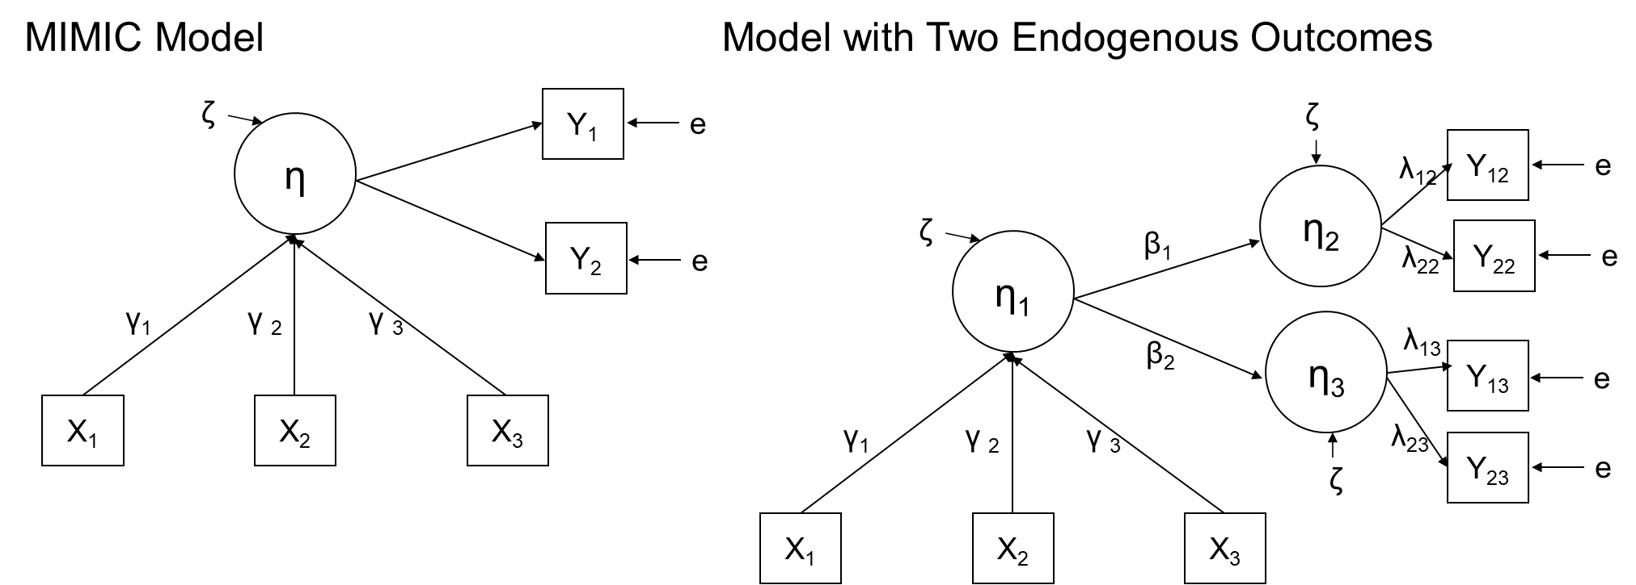

The loadings from the formative indicators to the formative construct are not stable but vary depending on the content of the reflective indicators – meaning that if you swap out one reflective indicator for a different one in the data set the loadings on formative indicators will change. There is little guidance on what kind of constructs or variables are appropriate for establishing identification of a formative measure when assessing construct validity.

Sample Specificity

Measurement model tests will vary from sample to sample. This is normal because our samples are rarely drawn randomly from the population but are instead “convenience” samples – someone gave us access to data in some patch of the population. Accordingly, there can be a great deal of sample specific variation in each draw and estimated results vary from the population values.

The measurement model for reflective variables is precise. The loadings from the construct to the indicator are theoretically predicted to be one, the loadings for each reflective indicator are predicted to be equal to each other, and the error of the indicator is predicted to be zero. In tests of the measurement model, the actual estimates from a sample will vary considerably from the theoretically predicted model but the standard for evaluating the fit of the measurement model is unambiguous.

In contrast, the standards for evaluating the adequacy of formative and multidimensional measurement models are rarely specified. The lack of specificity in the measurement introduces ambiguity when evaluating the tests of the measurement model. What should be the value of the weights of the causal indicators in a formative model? Given that the organizational sciences routinely use convenience samples, how much variation in the tests of a formative measurement model from one sample to the next is acceptable signifying an adequate model? These questions are should be, but are often not, addressed when researchers develop and test formative or multidimensional models.

Whether a construct should be measured with formative or reflective measures is a theoretical issue which is not resolved by a statistical test. Regardless of whether the measure is designated as reflective or formative, it is essential to clearly specify the theoretical measurement model and to marshal empirical evidence in support of construct validity.

What to do? Or re-specifying formative models as reflective

The causal processes discussed by advocates of formative measures do, in my opinion, often exist. Increasing the values of job satisfaction facets (e.g. pay, relationships with supervisors and co-workers, benefits, interesting work and so on) will cause overall job satisfaction to increase. However, it is simple to model the predicted causal processes with reflective measures.

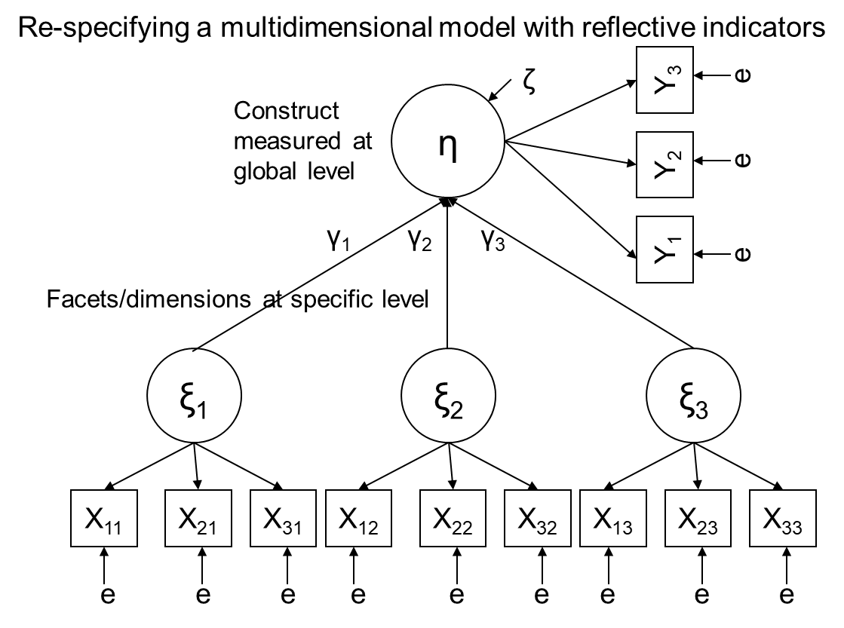

The key difference between the model above and typical conceptions of formative/multidimensional models is in the recognition that constructs can be measured at different levels of specificity. For example, job satisfaction can be measured in ever more finely specified facets (e.g. satisfaction with the office carpet, satisfaction with office social events) or can be measured at higher levels of abstraction. A more abstract, global assessment of satisfaction is represented by the item, “overall, how satisfied are you with your job?”

The model above/below incorporates both the prediction that facets of satisfaction will increase global satisfaction along with the advantages of reflective measures and the associated precise procedures for assessing validity.



